In Javasdcript Apicall

Var http=new XMLHTTPRequest();

http.open(“get”,url);

http.send();

http.Onreadystare change

coming to angular

https://jsonplaceholder.typicode.com/posts

Angular is providing the HTTP client module which allows the developers to send the Http requests to make api calls to use http services.

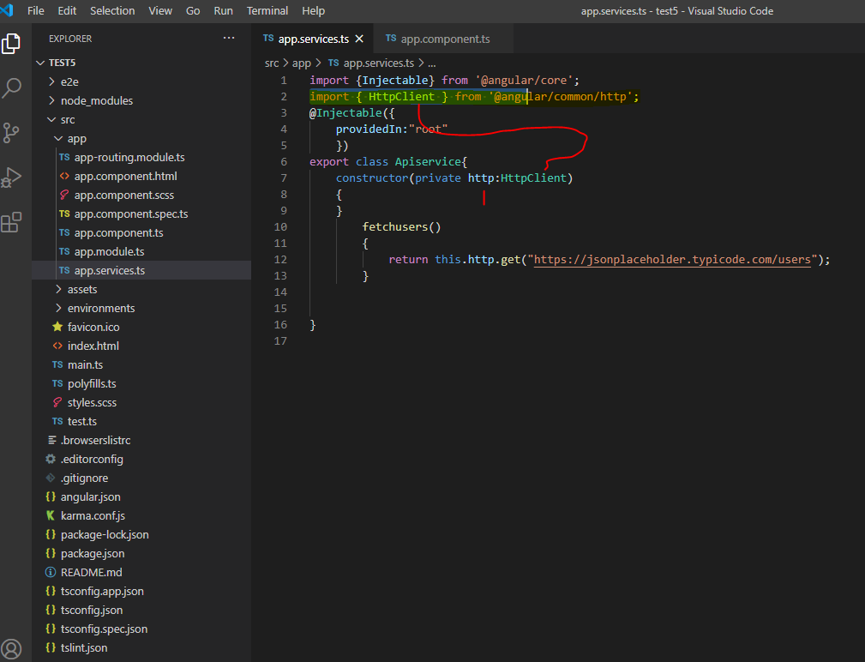

***RESTFUL API’s***